***Not So Safe!***

**An alert for parents on the vaping and e-cigarette trend among students.**

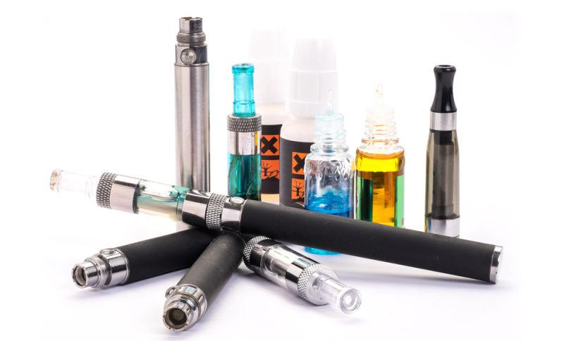

The Massapequa School District along with the Massapequa Takes Action Coalition would like to inform parents of our collective concern regarding the growing use of e-cigarette and vape pens and the associated risks to our students.

There is a host of conflicting and confusing information out there regarding the use of these Electronic Nicotine Delivery Systems (ENDS) and what young people are using them for. These ENDS are often referred to using the term e-cigarette which also includes vape pens and vape mods.

These devices create an aerosol by using a battery to heat up liquid that usually contains nicotine, flavorings, and/or other additives. Users inhale this aerosol into their lungs. These devices can also be used to deliver cannabinoids such as marijuana, and other drugs. One of the more alarming aspects is that these devices can often make marijuana use undetectable as they do not produce an odor like traditional methods of marijuana use.

In 2014, the Centers for Disease Control and Prevention [reported](http://www.cdc.gov/media/releases/2015/p0416-e-cigarette-use.html) e-cigarettes were the most commonly used tobacco product among middle and high school students, with an estimated 2 million users in that age group. We are particularly concerned that these products are seen as safe by students resulting in a growing number of nicotine dependent young people.

We are urging parents to take a look at the available resources and articles regarding the “vape” culture and inform themselves of the risks to children and teens.

The use or possession of these devices on school grounds is a violation of the code of conduct and is subject to disciplinary action.

As a school district, we are encouraging parents to speak with their teens about concerns about these products.

NIDA. (2017, June 27). Electronic Cigarettes (E-cigarettes). Retrieved from https://www.drugabuse.gov/publications/drugfacts/electronic-cigarettes-e-cigarettes on 2017, November 22 Websites for Additional Information

<https://www.drugabuse.gov/publications/drugfacts/electronic-cigarettes-e-cigarettes>

<https://e-cigarettes.surgeongeneral.gov/>- this website also has a parent tip sheet for discussing this topic with your teen.

<https://www.centeronaddiction.org/e-cigarettes>

<https://www.health.ny.gov/prevention/tobacco_control/reports/statshots/volume10/n1_youth_cigarette_and_ends_use.pdf>

For additional information please contact your school social worker; Marisa Boulukos at Berner Middle School 516-308-5750, Kimberly Hession at Ames Campus 516-308-5850 and Diane Marascia and Joanne Waters at MHS 516-308-5950. Yes Community Counseling Center at 516-799-3203.